Practical No. 6
Aim : Generate a Time Division Multiplexing (TDM) signal
using relevant simulation software
Name : Danish Altaf Solkar | Class : CO - B
Enrolment no. : 24111590805 | Batch : 2
Code :-
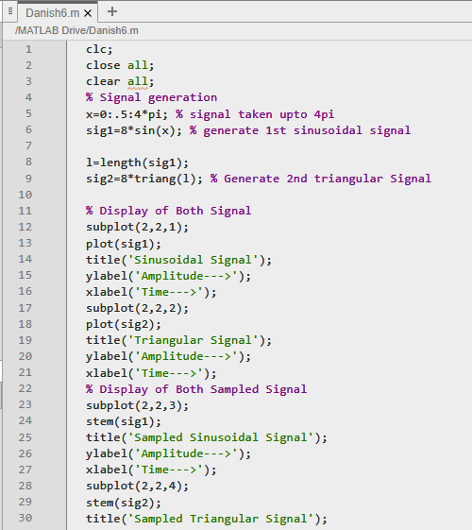
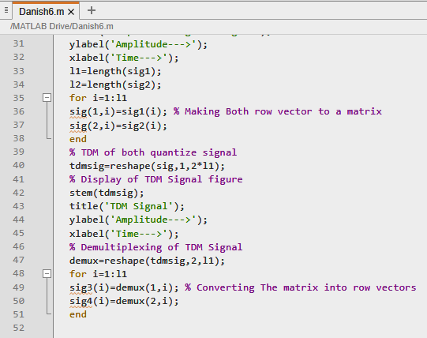
OUTPUT :-
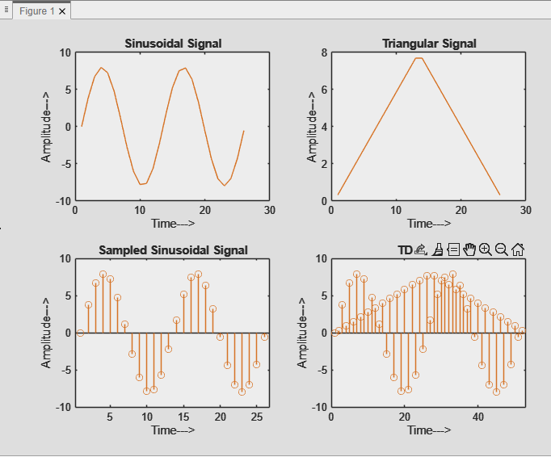

Process related  (15) | Product related  (10) | Total Marks  (25) | Signature

